

Project Members: Rodgers Kaunda

Project Name: Continuous Assessment Part 1

Student Numbers : x20208740

Module : Introduction To Databases

# ***Username and Password***

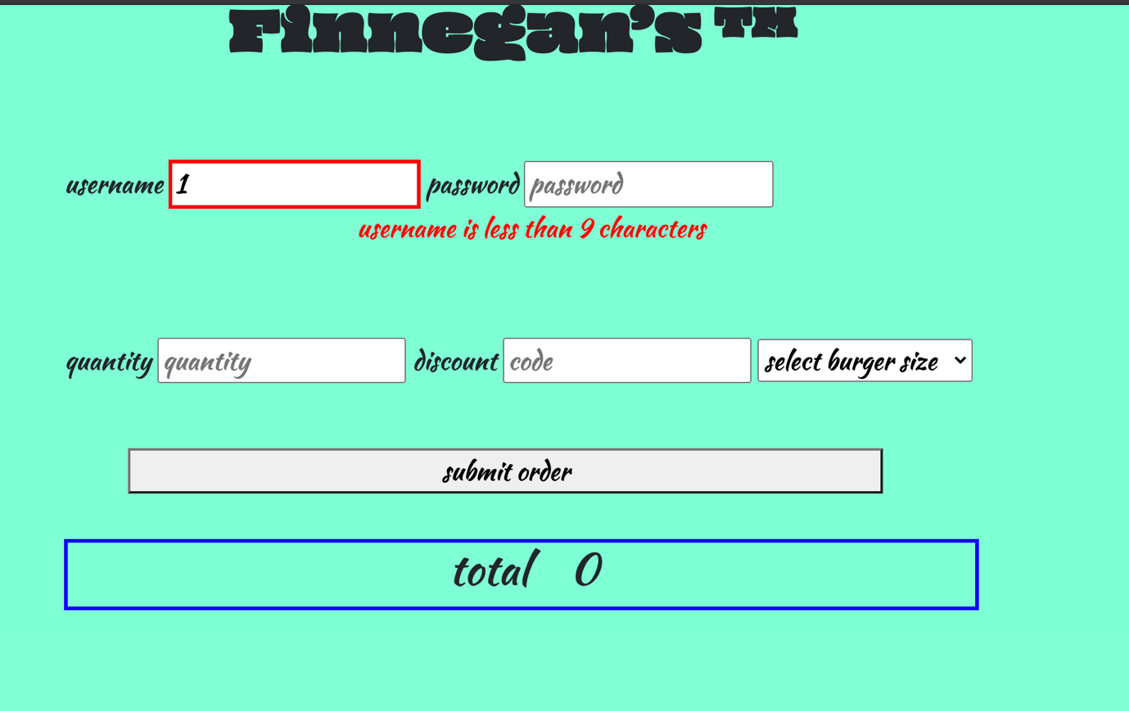

In the above username input , each keypress is tracked with keypress event. If there is less than 9 characters in the input field the border is highlighted in red and a message is outputted.

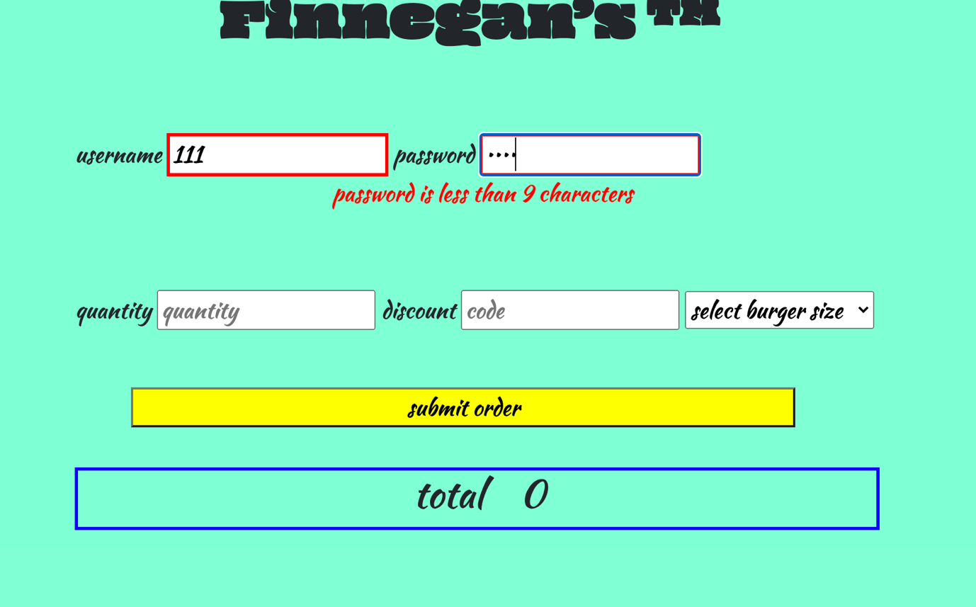

In the image above the border is higlighed red letting the user know theres an issue with that input field in username, no message is outputted cause we are in a different input field. In the password input field its a similar keypress event as the username cause we are typing characters in the password input . it shows a message an a red border cause we are in the password input.

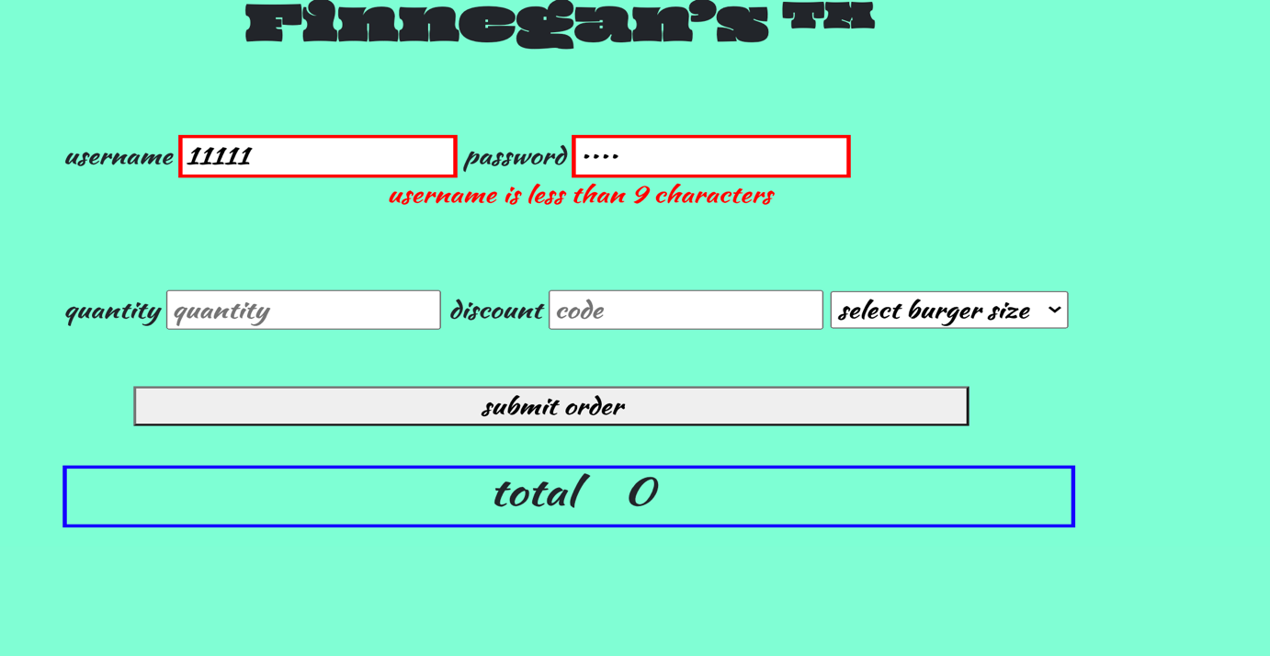

If you had to click back into the username input and started typing and the username length is still less than 9 characters the message will appear again depending on what input field you are typing in.

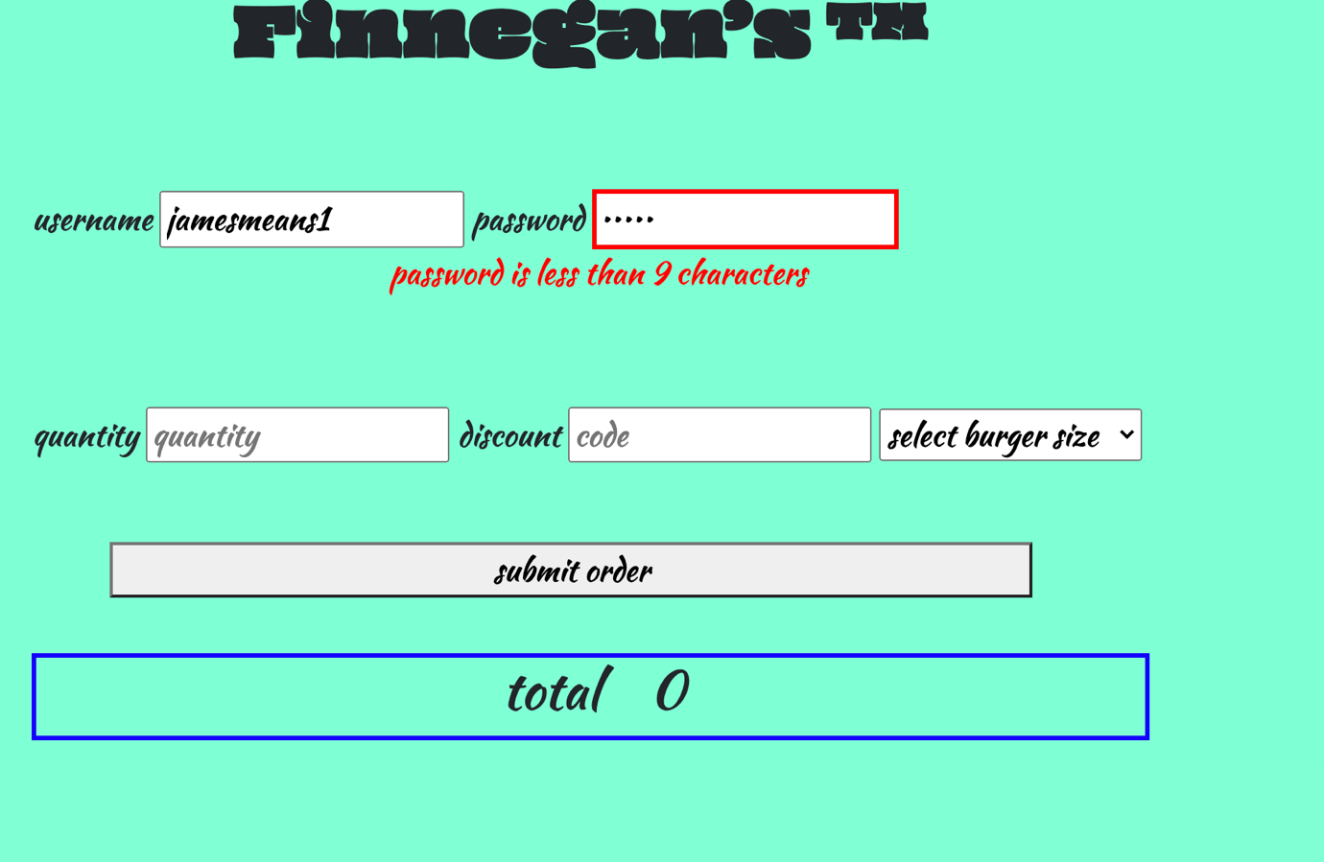

If the characters in the input field exceeds 9 characters the red border is removed.

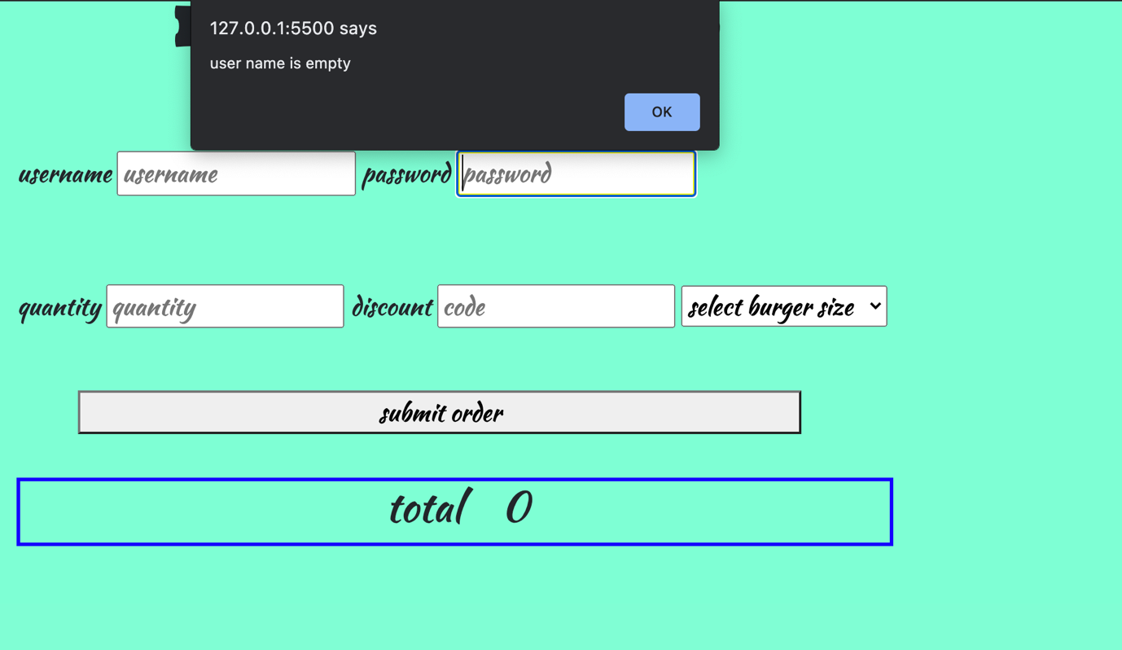

If you clicked on the password input in an attempt to type in the password you will get an alert that the username field is empty.

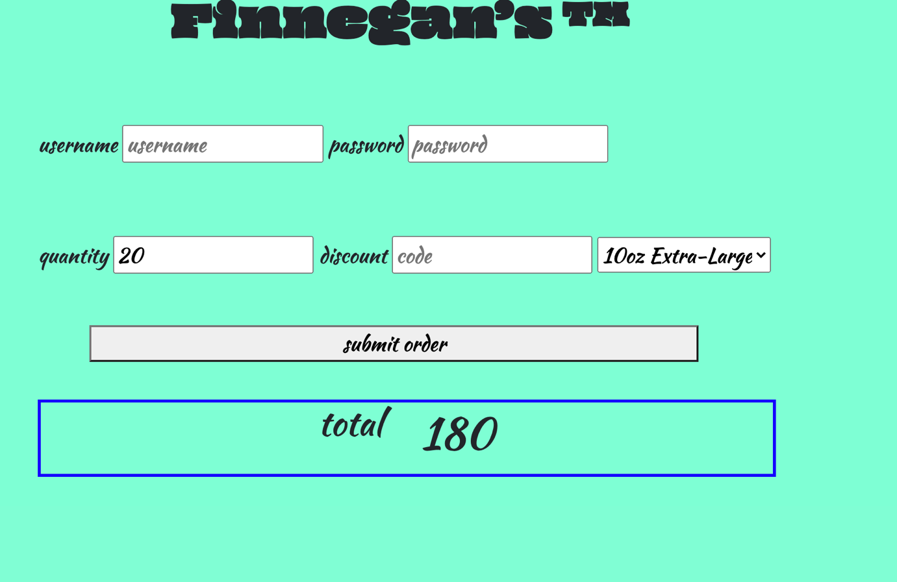

When you enter the quantity and the selected type of burger from the drop down and click submit the order total will be calculated by clicking submit.

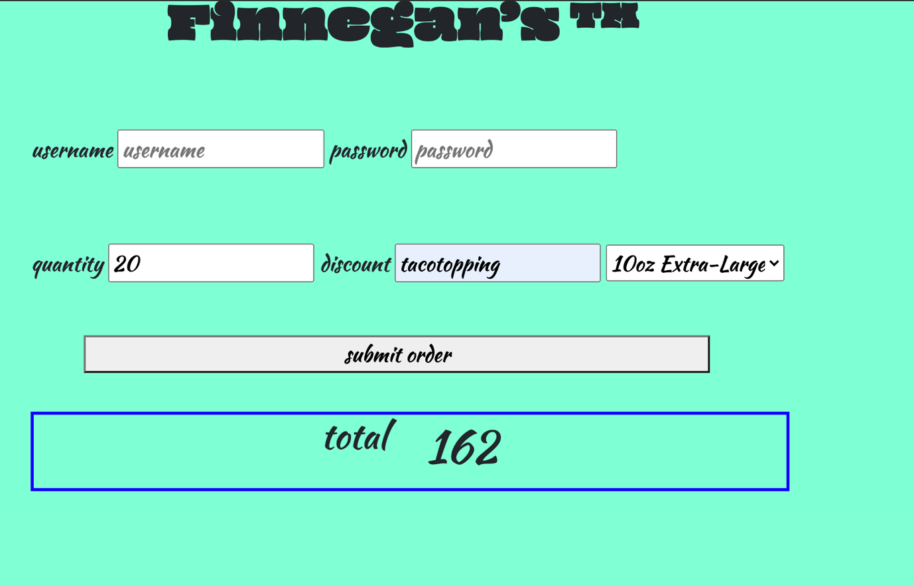

If user inputs a discount code it will be applied to the order when user clicks submit.

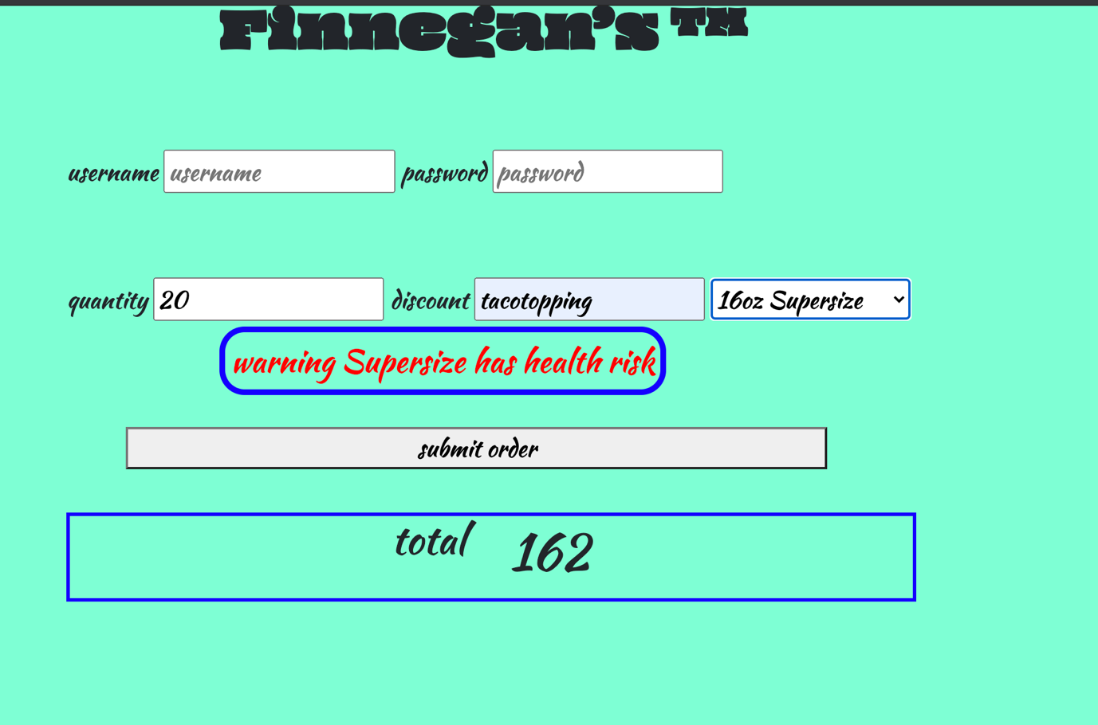

As soon as the user selects the 16oz Supersize it will warn the user about the burger.

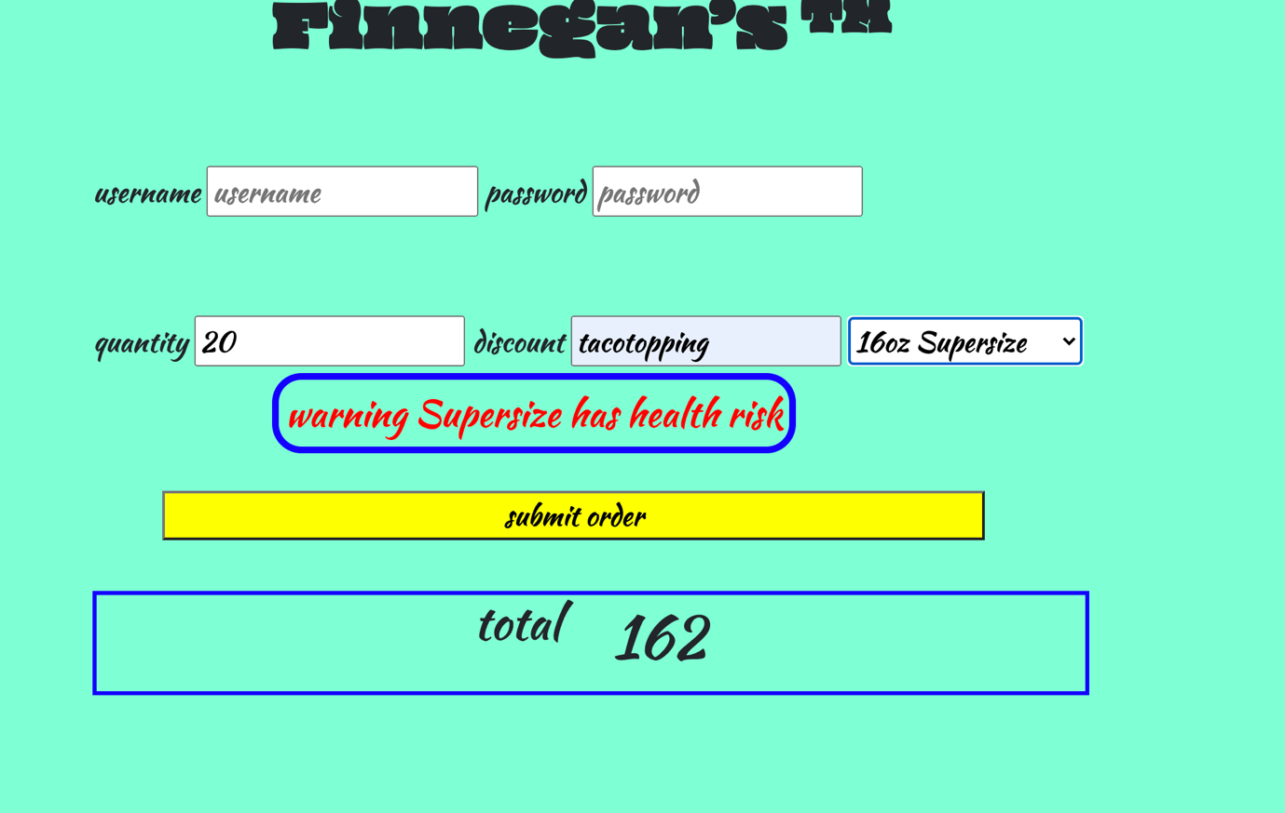

In the app hover effect was added to show the element they are hovering over. It is applied to all the elements like input and button.

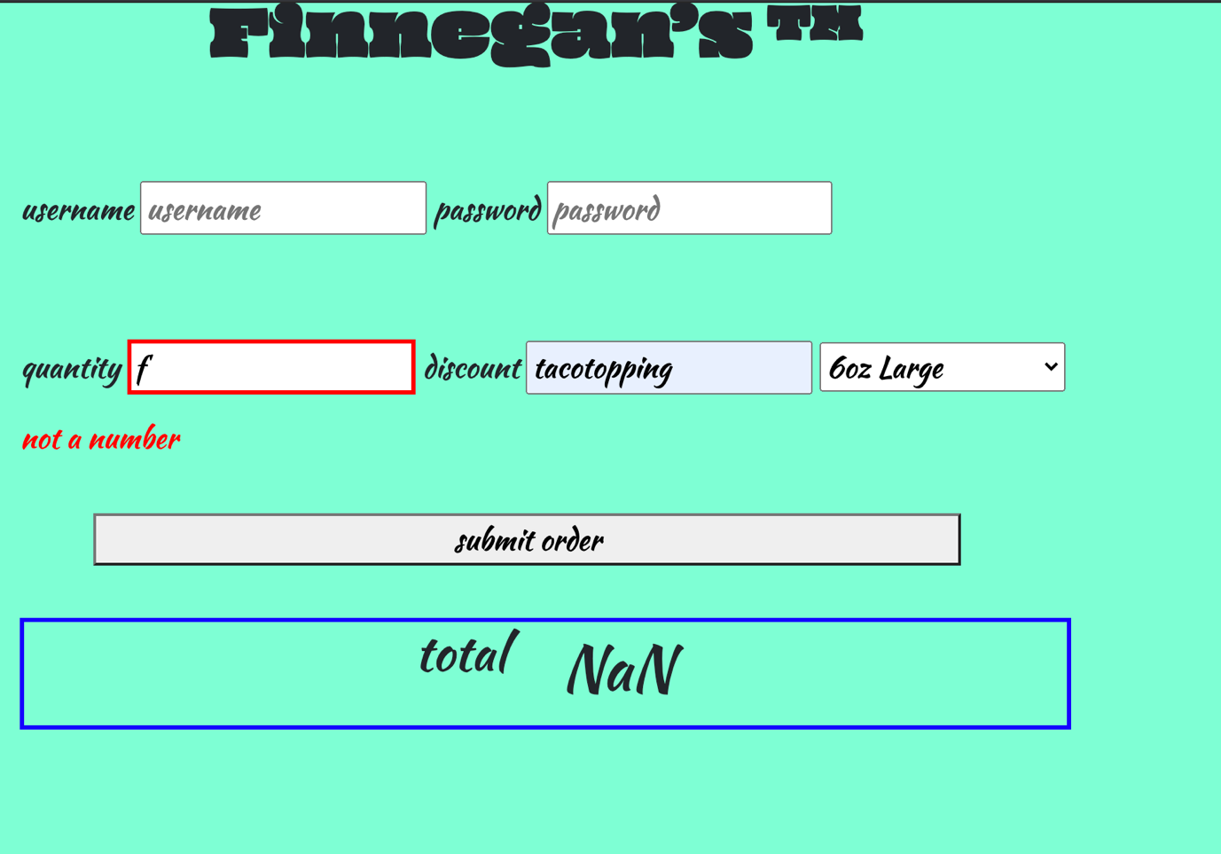

If you try to submit an order and the quantity is not a number it will give a message and the border will be highlighted red. As well the total will give its not a number.